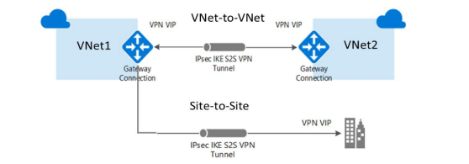

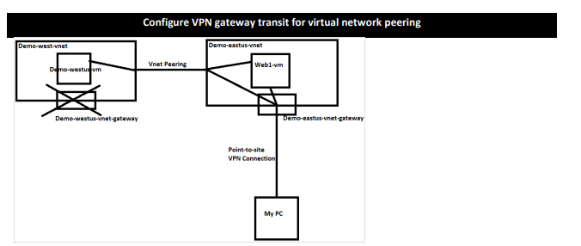

hat This Architecture Represents
This is a centralized network design where:
- One main network = Hub VNet
- Multiple smaller networks = Spoke VNets
- On-premises network connects to Azure
- Traffic is controlled through a central point

Components in the Diagram

1. On-Premises Network
Your company’s internal data center
- Offices
- Local servers
- Internal applications
Connected to Azure using:
- Azure VPN Gateway
- OR Azure ExpressRoute

2. VPN / ExpressRoute

VPN
- Uses internet
- Encrypted connection
- Cheaper

ExpressRoute
- Private connection (no internet)
- Faster & more secure
- Used by enterprises

3. Hub Virtual Network (Central Network)
The heart of the architecture

Contains:
- Network Virtual Appliance (NVA)
- Firewall / Routing system
Example name:
Demo-eastus-vnet

4. Router NVA (Network Virtual Appliance)
A virtual router/firewall
- Controls traffic between networks
- Applies security rules
- Routes traffic
Examples:
- Azure Firewall
- Third-party firewall (Cisco, Fortinet)

5. VNet Peering
Connects Hub with Spokes
Key feature:
- Private communication (no internet)
- High-speed connection

6. Spoke Virtual Networks
These are separate application environments
Examples:
- App1 VNet
- App2 VNet
- Dev/Test VNet
From your image:
Spoke 1 → Demo-westus-vnet
Spoke 2 → Demo-centralus-vnet

7. Route Tables (Important)
Each spoke has:
Route Table

Purpose:
- Controls where traffic goes
- Forces traffic through Hub (NVA)
Example:
All traffic → Hub → Firewall → Destination

How Traffic Flows

Scenario 1: User from On-Premises → Azure App
On-Premises → VPN/ExpressRoute → Hub → Spoke → Application

Scenario 2: Spoke-to-Spoke Communication
Spoke 1 → Hub (Firewall) → Spoke 2
Direct communication is NOT allowed
Must go through Hub (for security)

Scenario 3: Internet Traffic
Internet → Hub Firewall → Spoke App

Why This Architecture is Used

1. Centralized Security
- Firewall only in Hub
- No need in every Spoke

2. Cost Efficient
- Shared services (VPN, Firewall)
- Avoid duplication

3. Easy Management
- All routing controlled in one place

4. Scalable
- Add new spokes anytime

Real-World Use Case
Example: Banking Application
Network | Purpose
Hub VNet | Security + Routing
Spoke 1 | Web App
Spoke 2 | API
Spoke 3 | Database

Important Concepts (Interview)

Hub VNet
Central network for shared services

Spoke VNet
Isolated network for applications

VNet Peering
Connect VNets privately

NVA
Controls and filters traffic

Simple Visualization
On-Premises
│
VPN / ExpressRoute
│
HUB
(Firewall)
/ | \
Spoke1 Spoke2 Spoke3

When to Use This Architecture?
Use Hub-Spoke when:
- Large enterprise system
- Multiple applications
- Need strong security
- Hybrid cloud (on-prem + Azure)

